RISC-V Simulator Technical Specification
Version: 0.03 | 2/12/2022
Editors: Hector Soto
Created By: Hector Soto (sotohec@pdx.edu)
December 2/11/2022
Preface

This document describes the functionality of the RISC-V Simulator (RVS).
Table of Contents

Section 1 – Introduction | Page 1
Section 2 – Code Specification | Page 2
2.1 – Simulated Memory | Page 2
2.2 – Simulated Memory Structure | Page 3
2.3 – Registers | Page 3
2.4 – Instructions | Page 5
Section 3 – Simulation | Page 7

Section 1 – Introduction

System Requirements: 64-bit OS with more than 4 GiBs of memory.
^ This program can possibly allocate more than 4 GiBs of memory.

This simulator will be coded in C++.

This simulator will simulate the (RISC-V) RV32I Base Integer Instruction Set as described in (https://riscv.org/wp-content/uploads/2019/12/riscv-spec-20191213.pdf). It will have a default max program size of 64 KiB or smaller. Since each instruction is 32-bits, this means a default limit of 2048 instructions. With flags, this limit can be changed.

1.1 – Functional Description

The RISC-V Simulator (RVS) will accept input parameters such as a memory image file, starting address (defaulted to 0), and stack address (defaulted to 65535).
Section 2 – Code Specification

This section describes the code structure of the simulator.
It will describe some of the classes, functions, structures, and variables used in the simulation, including some of their relations to one another. A Pseudo-Definition is a non-final definition in C++ code or similar to represent the logic or structure of things such as functions, classes, etc. Do not expect a Pseudo-Definition to be a 100% accurate representation of implemented code.

Note: memory => user’s memory. simulated-memory => memory affected by simulated instructions.

2.1 – Simulated Memory

The RISC-V Simulator (RVS) needs to simulate memory that instructions read and write to. Furthermore, the size of the simulated memory will default to 4 GiB as that’s the limit of the simulated ISA (RV32I). Since a default maximum of 64 KiB of instructions can be loaded, instructions will be loaded and ran from simulated memory. A hierarchy for memory management is defined below.

Table 2.1.0
Dynamic Memory Specs
Alignment | 4-byte (2 LSBs = 00)
Max Size | 4 GiB
Memory Allocation | Dynamic
Address Space | Circular
Address Range | 0x00000000 → 0xFFFFFFFF
Circular: Addresses 0x00000000 and 0xFFFFFFFF are adjacent. Decrementing the former will give the latter and incrementing the latter will give the former.
Dynamic Memory Allocation: Memory will be dynamically allocated when an instruction stores or loads to a memory location that hasn’t been referenced yet.

Class Pseudo-Definition
class SimMemory
{
public:
uint32_t *GetDataPointer(uint32_t Address); //Get pointer at address.
uint32_t Load(uint32_t Address, int Type); //Type indicates type of load.
Store(uint32_t Address, uint32_t Data, int Type); //Type indicates type of store.
private:
MemPart Partition[32]; //32 element array of Memory Partitions.
}

Function Pseudo-Definitions
uint32_t Load(uint32_t Address, int Type)
{
return data at given address based on load type;
}

Store(uint32_t Address, uint32_t Data, int Type)
{
store data at given address based on store type.
}

uint32_t *GetDataPointer(uint32_t Address) //Will be utilized by both Load() and Store().
{
Go down memory hierarchy and allocate memory when needed.
//We’re returning a pointer to a 4-byte word. So the 2 LSBs are ignored.
//^^Memory is 4-byte word aligned by default.
return Pointer to 4-byte word that has data at that address.
}

Note: Despite returning pointers to 4-byte aligned addresses only, load/store instructions like LB and SB can still alter/reference individual bytes by modifying the 2 LSBs in the address returned by GetDataPointer().

2.2 – Simulated Memory Structure

The smallest unit of allocatable memory is the Page Element (PE). The PE is an array of 256 32-bit elements and each element will contain actual data that is loaded from or stored to simulated-memory.

A Page is a 32 element array of pointers to PEs. It can hold 32 KiBs of allocated memory.
A Memory Partition Element (MPE) is a 64 element array of Pages. It can hold 2 MiB of allocated memory.
A Memory Partition (MP) is a 64 element array of MPEs. It can hold 128 MiBs of allocated memory.
Simulated memory is a 32 element array of MPs. It can hold 4 GiBs of allocated memory.

Hierarchy: Simulated Memory → MP → MPE → Page → PE

2.3 – Registers

There are 33 32-bit registers. Register x0 is hardwired with all bits equal to 0. Data in general purpose registers x1-x31 will be interpreted as two’s complement signed integers, unsigned integers, or a collection of boolean values.
The pc (program counter) register holds the address of the current instruction.

Our simulation will use an array of 33 32-bit elements to represent registers x0 → x31. This array will be called the Register Array (RA). At the start of simulation, only registers x0, sp, pc, and ra will be initialized to zero. Register x0 can’t be overwritten and will always remain zero.

Table 2.3.0
Register Array Initial State
Array Index | Register | Value
RegisterArray[0] | x0 | 0
RegisterArray[1] | x1/ra | 0
RegisterArray[2] | x2/sp | 0
RegisterArray[3-31] | x3 → x31 | NA
RegisterArray[32] | pc | 0

2.4 – Instructions

There are four core instruction formats (R, I, S, U). All instructions are 4-byte aligned in memory. Instruction formats B and J are two extra variant formats to handle immediates.
The RISC-V calling convention described in the following link will be used.
https://riscv.org/wp-content/uploads/2015/01/riscv-calling.pdf
Here is a useful table from above link.
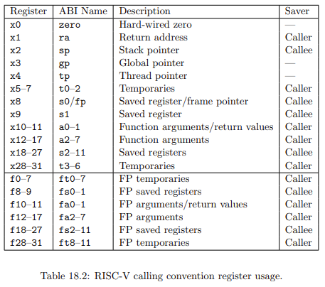

Instructions in the simulator have the same encoding from the link above and is available in the useful table below.
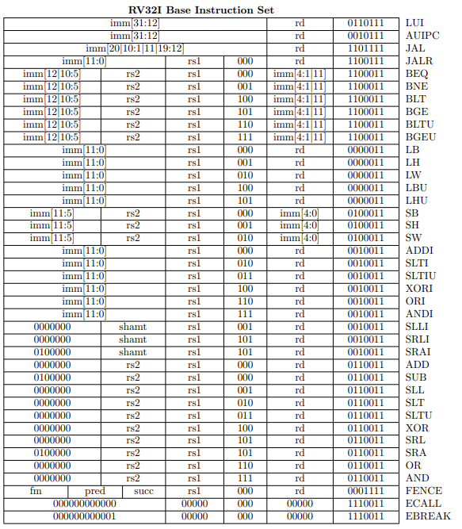
Section 3 – Simulation

